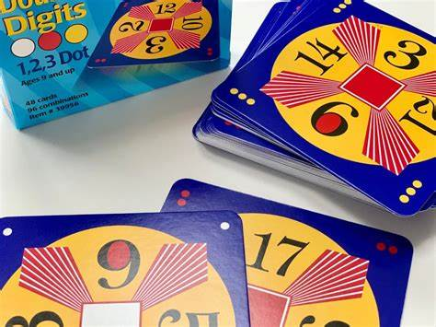
Wednesday 14th September
Dear Parents/ Carers,
Your child has expressed an interest in attending Make 24 Maths Club on Thursdays after school. The club will run from 3.20pm to 4.15pm. The dates of the club are listed below:

Thursday 29th September
Thursday 6th October
Thursday 13th October
Thursday 20th October No club due to Teaching & Learning Week
Half-term
Thursday 3rd November No club due to Parents’ Evening
Thursday 10th November
Thursday 17th November
Thursday 24th November
Thursday 1st December
Thursday 8th December
Thursday 15th December No club due to Teaching & Learning Week

The club will take place in Juniper Classroom (Miss Flook’s Room) but collection will be from the main entrance. If your child would like to attend, please return the permission slip below to Miss Bird by Tuesday 20th September.

Kind regards,
Miss Bird (Deputy Head Teacher)
______________________________________________________________
Make 24 Club Miss Bird
I would like my child to attend the club.

Parent/ carer signature: Date:

Emergency contact number:

Medical needs:

Going home arrangements:

