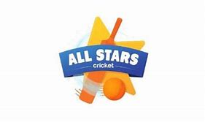

All Stars Cricket Club at
Leckhampton Primary School

Dear Parents,

We are working alongside the Gloucestershire Cricket Foundation to offer pupils at our school the opportunity to access ‘All Stars Cricket’ as an after-school club this summer.

This offer is aimed at 5 to 8-year-olds (Year 1, 2 and 3). If your child/ children are already attending All Stars at a local club, please continue to do so. This opportunity is targeting children who wouldn’t be able to attend a club session.

All Stars Cricket is a great programme that is tailored for younger age children. More information can be found here: All Stars Cricket | Gloucestershire Cricket Foundation

The total cost for the 6-week programme that includes a bat, ball, rucksack, and personalised T-shirt that will be delivered to your home address is £40.

All information including dates, times and how to book can be found here: https://ecb.clubspark.uk/AllStars/BookCourse/2a618b81-f1df-4d47-bff3-03ffa5b2b0dc

This specific opportunity is only available for pupils at your school. Please note, the maximum number of children for this programme is 24, it will be first come, first served.

If you have any questions, please contact Chris Munden, his contact information is on the link above.

Kind regards

Chris Munden

