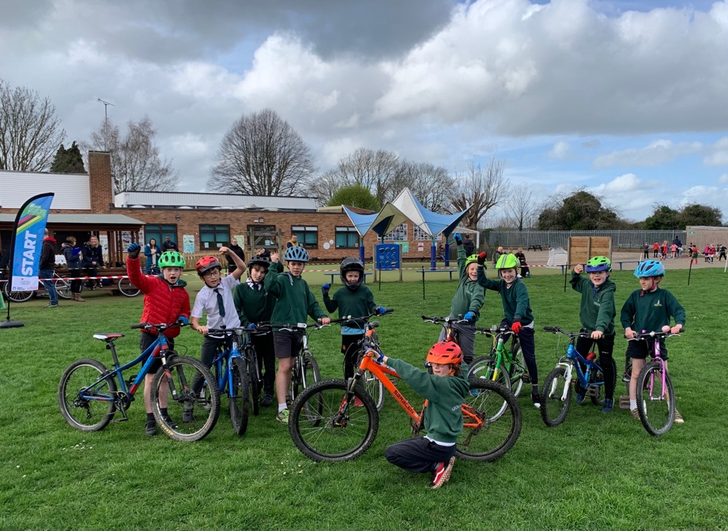
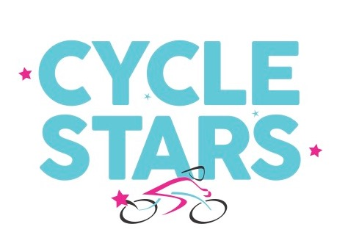

Cycle Racing Leckhampton School

No one told Leckhampton School Cycling team, that they weren’t expected to win their first league race against Hempsted School, how wrong we were as the team claimed their first victory at an away race. We mustn’t become complacent as we now go on to race the current league leaders St Marks at a home event.

Have you got what it takes to be a winner! We are looking for new riders to join our after-school club, you don’t have to be super fit or a skilled cyclist, led by an accredited British Cycling Coach, you will become the best you are. All we ask in return is commitment and full participation in the coaching sessions.

What is cycle racing? Cycling disciplines comes in many forms, Mountain Biking, Cyclocross, Circuit, Track, Time Trial, BMX and Speedway. Far too many to know which you would be best suited, but the principal is the same, first to the finish line wins!

We will introduce racing, give you coaching as to the principals of going fast, and give you the opportunity to try out racing in the school cycle race league.

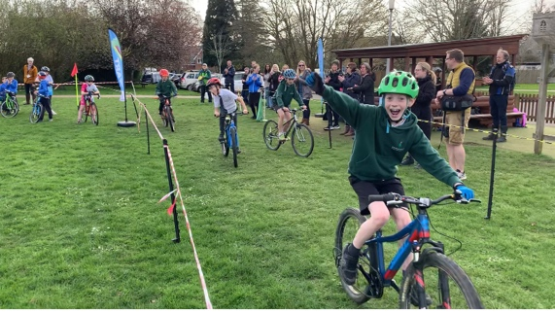
Who will it suit? If you are competitive that’s a good start! You don’t have to be particularly good at sports, it might be that you’ve never found a sport that suits you. All you need, is a helmet and a bike and a willingness to learn.

Your coach is very experienced at spotting talent, we have already identified 20 children from local schools who are now competing regular, 6 of which have become podium winners in 2022.

How much will it cost? Summer term is £48 this will include at least one race against another school with a registration fee of £2. Club will start on Monday 17th April 2023 and run for 8 weeks (excluding Bank Holidays)

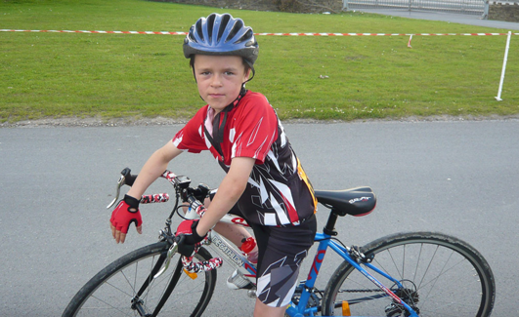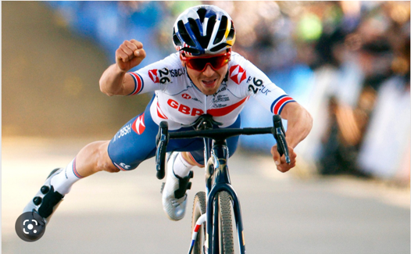

Tom Pidcock
Started racing at school, he was upset that in his first race he was beaten by a girl!
He has since become the World Champion at Mountain Biking, Cyclocross and a stage winner of the Tour de France.

Racings not for Girls!
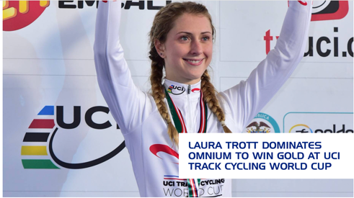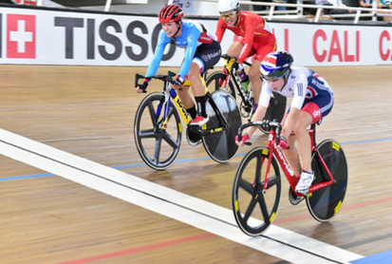
Laura Trott might disagree, she started cycling to help her mum lose weight, she has since won 5 Olympic Gold medals in Track Racing and is the National Champion at Road Racing.

To participate in the school cycle league parents/guardians are required to complete an agreement form available from reception

If you are interested in joining Leckhampton cycle club, please complete the attached slip to info@cyclestars.co.uk. A representative from Cycle Stars will be in touch shortly.

Cycle Stars after school club

NAME: _ _ _ _ _ _ _ _ _ _ _ _ _ Email: _ _ _ _ _ _ _ _ _ _ _ _ _ _ _

Age: _ _ _ _ Year: _ _ _ _ _ Parents name: _ _ _ _ _ _ _ _ _ _ _ _

Address: _ _ _ _ _ _ _ _ _ _ _ _ _ _ _ _ _ _ _ _ _ _ _ _ _ _ _ _ _ _

_ _ _ _ _ _ _ _ _ _ _ _ _ _ _ _ _ _ _ _ _ _ _ _ _ _ _ _ _ _ _ _ _ _ _

_ _ _ _ _ _ _ _ _ _ _ _ _ _ _ _ _ _ _ _ Post Code: _ _ _ _ _ _ _ _

Home Telephone: _ _ _ _ _ _ _ _ _ _ Mobile: _ _ _ _ _ _ _ _ _ _ _

